**Cannot Calculate ACDD- ASOC Issue**

User is unable to calculate ACDD on USRP screen, hence unable to release the order into the system. Whenever you see such issue mentioned on TT, open Ticket against ASOC with ITEM ID.

**Steps to find ITEM ID in logs.**

1. Login to clpi055.sldc.sbc.com
2. Go to directory **cd /opt/frame/log/ot_server/asoc_server/response**
3. Search by userid of the person getting the issue **ls -ltr | grep -i lt2161_whsle or (grep AT115 *nh165n_retail*)**
4. vi file name(last updated)

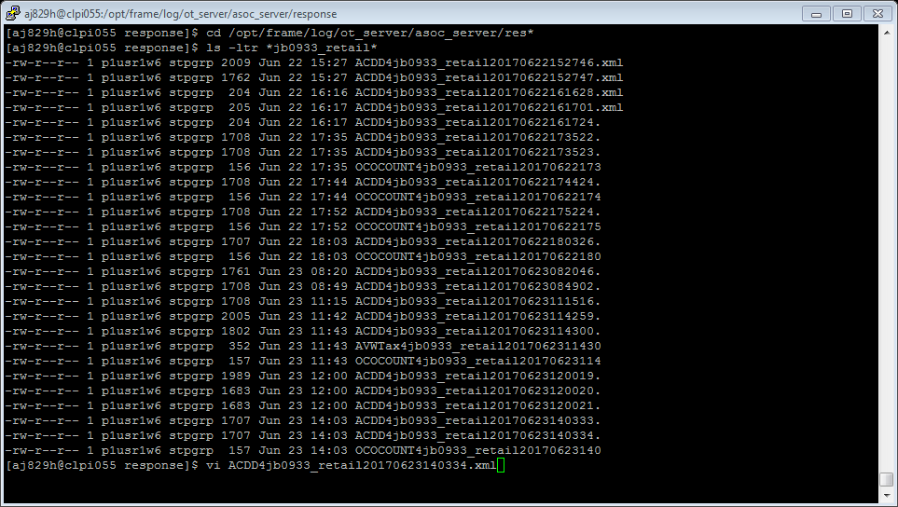

**To find userid, run the below SQL query.**

1. select userid from user_info where hrid="lt2161"

**NOTE:** HRID is the ATT ID of the person getting the issue.

Once you find the ITEM ID in logs, Engage ASOC via IE Ticket. Below are the details to create an ASOC IE Ticket.

|  |  |  |  |
| --- | --- | --- | --- |
| **Application Name** | **Managing Org** | **Active Org** | **Work Queue** |
| ASOC | IT-ENTRPRS | IT-ENTRPRS-SDEL | ASOC |